**Application Look and Guidance:**

**1.Need to select Promotion Cd from the dropdown list**

**2.The Qnty is editable and need to fill the numeric value**

**3.Hit the Total button to calculate the price.**

**Initial Screen:**

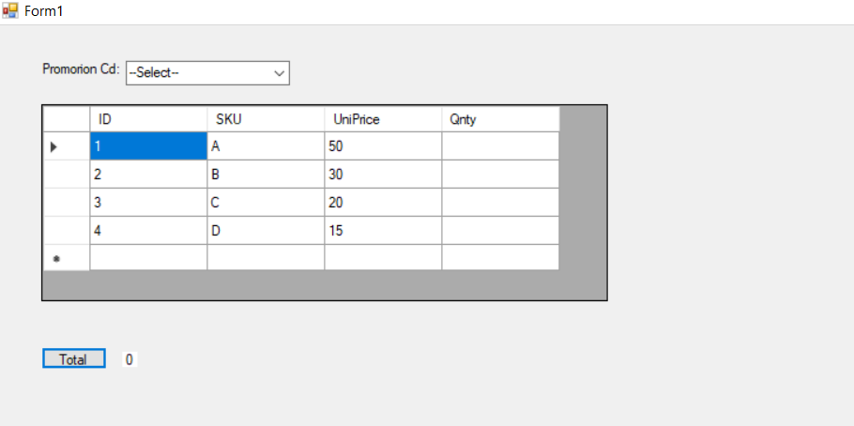

**Validation (In case hit Total button without entering the Qnty):**

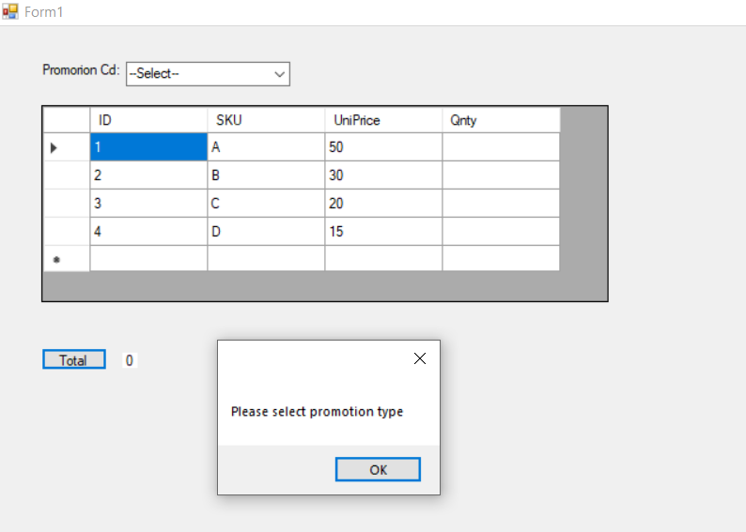

**Promotion 1: N Item of a SKU**

**1.Enter the value and hit the Total button**

**130+30+20 = 180 (3 A’s, 1B’s, 1 C selected)**

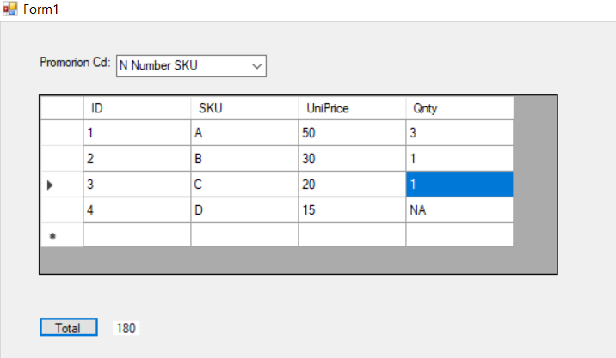

**130+45+20 = 195 (3 A’s, 2B’s, 1 C selected)**

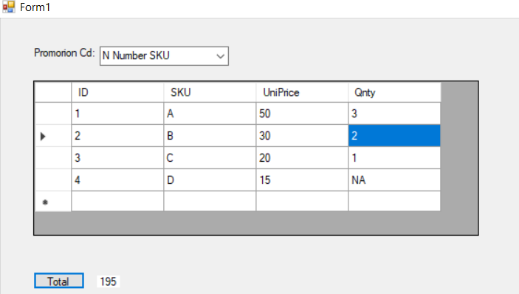

**2*130 + 50 + 2 * 45 + 30 + 3*20 = 490 (7 A’s, 5B’s, 3 C selected)**

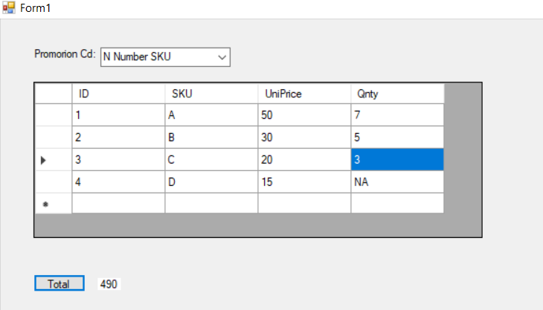

**Promotion 2: SKU1 & SKU2:**

1. **1.Enter the value and hit the Total button**

**2*130 + 50 + 2 * 45 + 30 + 30 = 460 (7 A’s, 5B’s, C + D selected)**

